Name:malak wessam
Faculty of computers and data science Alexandria university
Coffee Sales Dashboard
Project Overview
This project presents an interactive Coffee Sales Dashboard built using Microsoft Excel.
The goal of the dashboard is to analyze sales performance over time, identify top customers, and evaluate sales distribution by country, roast type, and package size.
1-Data Cleaning & Preparation
Performed data consolidation by merging three raw data sheets into a unified analytical dataset. Applied conditional logic (IF functions), lookup functions (XLOOKUP/VLOOKUP), duplicate removal, and data formatting to ensure data accuracy and consistency prior to pivot-based analysis and dashboard development.
2-Pivot Table Analysis
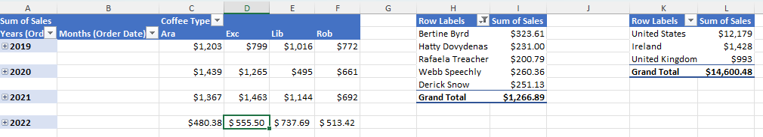
After completing data preparation, Pivot Tables were used to transform the transactional dataset into structured analytical views ,Time-Based Analysis to Identify trends, seasonality, and performance fluctuations over time, Customer Performance Analysis Applied sorting and filtering to extract Top 5 customers ,Geographical Analysis to Compare regional revenue distribution.

3-Dashboard Development
The final dashboard was designed as an interactive executive summary to provide dynamic insights into coffee sales performance.
All visual components are powered by interconnected Pivot Tables, enabling real-time filtering and analysis. Slicers were implemented for Roast Type and Package Size, allowing users to segment sales performance by product category instantly.
Additionally, a Timeline filter was integrated to enable time-based analysis at both yearly and monthly levels, supporting trend evaluation and seasonal performance assessment.
All charts are synchronized with these controls, ensuring that any filter selection dynamically updates the entire dashboard.
This interactive structure enhances usability and allows decision-makers to explore data efficiently without modifying the underlying dataset.
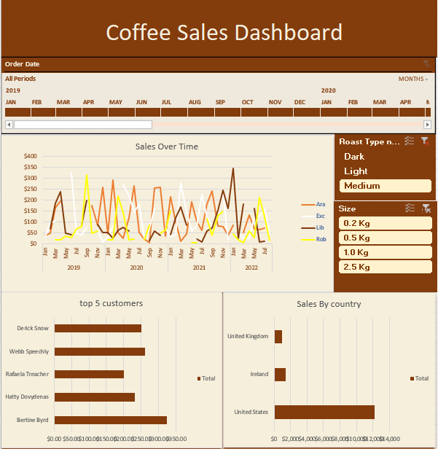

4-Key Insights
- The United States generates the highest overall revenue compared to other countries, indicating a strong market presence and customer demand in that region.
- Sales analysis shows that Dark and Medium roast types generate the highest total revenue compared to Light roast, indicating stronger customer preference for richer flavor profiles.
- The 2.5 kg package size records the highest sales volume, suggesting that customers tend to purchase in larger quantities, which may reflect bulk buying behavior or business-to-business demand.
- The time-series analysis reveals noticeable revenue peaks across specific customers, Ara experienced a significant sales spike in September 2021,Lib recorded a major peak in January 2022.

5-Business Recommendations
Since Dark and Medium roast types generate the highest sales, the company should:
- Increase inventory allocation for these roast types.
- Prioritize them in marketing campaigns.
- Offer bundle promotions centered around these high-demand categories.

Additionally, as the 2.5kg package size drives the highest revenue, targeted promotions for bulk purchases could further increase overall sales volume.
The strong performance of the 2.5kg size suggests potential business or high-consumption customers. The company could:
- Introduce loyalty programs for bulk buyers.
- Offer subscription-based purchase models.
- Provide volume discounts to encourage repeat purchases.

Time-based sales fluctuations indicate potential seasonality.
The business should:
- Plan inventory based on peak demand periods.
- Align marketing campaigns with high-performing months.
- Forecast demand using historical trends.

